InnoVia® Prospect Carts and Matrix Carts are not equivalent functions
In InnoVia, to send listings to your client, you simply added a listing to their prospect cart. Then you could send an email, or wait for the system to send the next automated email.
In Matrix, there is a cart feature. Carts are a place to park listings so that you can see them later. Think of them like sticky notes. You see a listing that you need to do something with later. So you write the number on a sticky note and stick it to your monitor. Later, you come back to it, look it up again and email or research it. Carts are like virtual sticky notes. Carts DO NOT send listings to your contacts.
If you have been sticking listings in carts thinking that your clients could see them, simply go into the cart, select everything that you want to send to your client, and use the email function at the bottom of the page to send it. This is not an auto email.
Updating your Imported Saved Searches (InnoVia® Prospect Carts) to Automated Emails in Matrix™
Most of your prospect listing carts from InnoVia have been transferred into Matrix as an imported saved search. In order for your contacts to receive automated emails you must change the imported saved searches into automated emails. Here are the steps to change your imported saved searches into auto emails in Matrix.
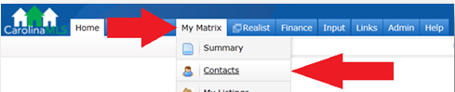
❶Log in to Matrix, go to “My Matrix” and click on “Saved Searches.”

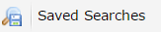
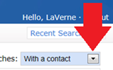
Optional: Once you are at the Saved Searches page you can Filter Saved Searches that are attached to a contact at the top right side.
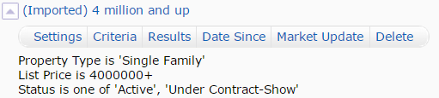
❷Listing carts that were transferred from Innovia into Matrix show up as (Imported). Click directly on the name of the saved search, below the search name there are several options, click “Settings” below the saved search name.
❸Important if your search criteria results are more than 500 listings this message will appear: This search finds too many listings to be an Auto Email. 500 max. You will have to change your criteria to narrow the results. If you’re on the Setting page click Cancel at the bottom (or use the back button) so your back to the saved search. Click the option “Criteria,” change your criteria, click “Save” – now continue to the next step.

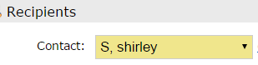
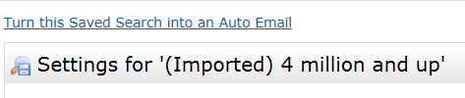
❹Once you click Settings the next page will have a link at the top left side called “Turn this Saved Search into an Auto Email” – Click this link.
❺ On the settings page your contact name should automatically appear in the recipients box, if you want, you can choose BCC: field and click the select box to send yourself a separate copy.
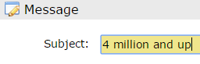
Retype the name of the saved search into the Subject line.
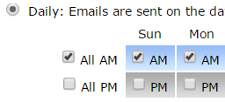
Review the default settings on this page.
- Welcome email (the first email your contact receives) and recurring email.
- Signature: Verify/Edit your email signature
- Criteria: View/Verify the criteria of this auto email.
- Settings: In this section you can enable concierge (A Concierge auto-email will first notify you of the updates and then allow you to determine which listings to approve and reject for your client), enable as a Favorite Search on the home page or allow your contact to show up in Reverse Prospecting
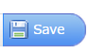
- Schedule: A regular auto-email will automatically update and email your contact based on your scheduler settings.
Click Save at the bottom of the page and an email will be sent to your contact.
Important - Your contact must click on the link in the email to activate this search.

Additional Matrix™ Auto-Email and Saved Search Tips

Reviewing your Sent Emails
Check every sent email in Matrix under My Matrix, Sent Emails. After setting up an Auto Email it may take a few minutes to show up in this section.

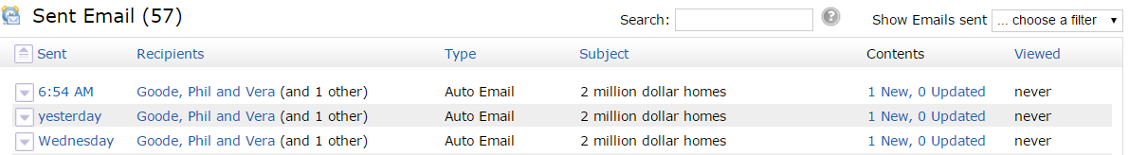

Auto Emails vs Saved Searches
Saved Searches and Auto-Emails are not the same thing; they are two different types of searches. To create a “New Saved Search” or “New Auto Email” you will have to run a “Search,” then go to the “Results” page (at the bottom click Save) to see the following options

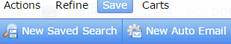

Managing your Auto Emails vs Saved Searches
To manage your saved searches or auto emails you must go the menu option “My Matrix” and choose accordingly - My Saved Searches or My Auto Emails (all searches can be accessed by contact as well – if attached)

 | Saved Search | Auto Email
Can be attached to a Contact | Yes (doesn’t have to be attached to contact) | Yes (must be attached to a contact)
Automatically sends emails | No | Yes
Can change into an Auto Email | Yes (under the saved search settings)
Can Change into a Save search | - | Yes (under the auto email settings)
Can be saved to a widget on the home page | Yes | Yes
Must have less than 500 listings to save | No | Yes (narrow down your criteria)

Auto-Emails Expires?
Automated emails in Matrix do not expire or go inactive unless,
- Your contact never clicks the link to access the Client Portal in the email after 80 days
- Your contact unsubscribes from receiving emails from this service
- Your contact has 90 days of inactivity on the Client Portal

How to Setup a New Auto email with a New or Existing Contact

- Setup a contact first:
- Click the "My Matrix" tab, and then click "Contacts"
- Click the "Add Contact" button toward the bottom of the page
- Fill in all the information you want for the contact. The only required fields are First Name and Last Name and email address. For multiple email addresses under one contact enter both addresses in the email field separated by a comma and space. When you are finished, click the "Save" button. Now you are ready to set-up a Search.

- Save a Search and Enable Auto-Email:
- Run a search (“Search” tab, select a property type, click Detailed) by entering your criteria. Click “Results” and then click the "Save" button at the bottom of the page. Click the "New Auto Email" button.
- Select the Contact in the drop down box to select (or create a contact if they are not in the drop down), if you want you can choose BCC: field and click the check box to send yourself a separate copy.
- Fill in the Subject for the new Auto Email. Your contact will see this every time an auto email is sent.
- Review the default settings on this page.
  - Welcome email (the first email your contact receives) and recurring email.
  - Signature: Verify/Edit your signature
  - Criteria: View/Verify the criteria of this auto email.
  - Settings: In this section you can enable concierge (A Concierge auto-email will only notify you of the updates and then allow you to determine which listings to approve and reject for your client), enable as a Favorite Search on the home page or allow your contact to show up in Reverse Prospecting
  - Schedule: A regular auto-email will automatically update and email your contact based on your scheduler settings.
- Click Save at the bottom of the page and an email will be sent to your contact

Important - Your contact must click on the link in the email to activate this search.

