Getting your PC ready for TEMPOTM
Minimum system requirements

  - Microsoft Windows 7, Vista or Microsoft XP operating system with Service Pack 2 or higher.
  - TEMPO is now available on your Mac! CMLS has arranged to offer its members IDS, an application you can run on your Apple computer that will give you full access to TEMPO. Contact the CMLS Help Desk or visit http://www.carolinarealtors.com/support/tempo/macs.aspx for more information.
  - Internet Explorer 6.0 with Service Pack 2 or higher. “IE 9 beta” is not supported.
  - Internet access with a 56 kbps connection speed (higher-speed cable modem, DSL or faster is recommended).
  - 1.8 GHz Intel Pentium 4 (or equivalent); recommended: 2.8 GHz, Intel Pentium.
  - 512 MB RAM (recommended 1 GB RAM).
  - 1024 x 768 resolution.
  - The ability to download and install ActiveX components (see “Installing ActiveX Controls for TEMPO” at the end of this document).

Configuring privacy/pop-up blocker

Pop-up blockers must be set up to accept/allow pop ups from tempo.carolinamls.com. To do this in Internet Explorer, please follow these steps:
- From Internet Explorer, select “Tools” and “Internet Options.”
- Select the Privacy Tab.
- In the Pop-up Blocker section, look to see if you have a check mark next to “Turn on Pop-up Blocker.”
  - If that selection is not checked, you can click “OK.”
  - If it is checked, click on “Settings,” then type tempo.carolinamls.com into the box labeled “Address of website to allow” and click “Add.”
- Click “Close” when you are done.

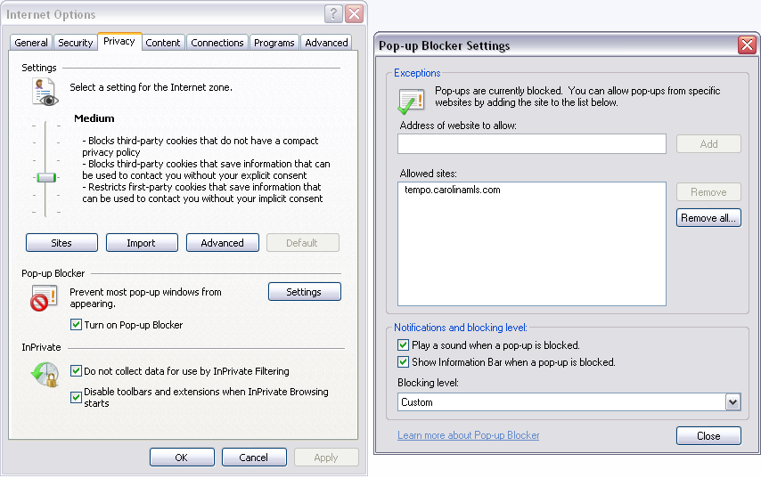

Other pop-up blocker programs are similar. If you do not know how to add an accepted/allowed site to your pop-up blocker, you will need to consult your pop-up blocker software vendor.

Configuring security

The TEMPO URL/website must be added to the trusted sites list in Internet options. Follow these steps:
- From Internet Explorer, select “Tools” and “Internet Options.”
- Select the Security Tab.
- Select “Trusted sites.”
- Click the “Sites” button. In the new window uncheck “Require server verification.” Then add each of the following three sites, clicking the “Add” button after each:
  - tempo.carolinamls.com
  - *.safemls.net
  - www.carolinarealtors.com
- Click “Close” when you are done.

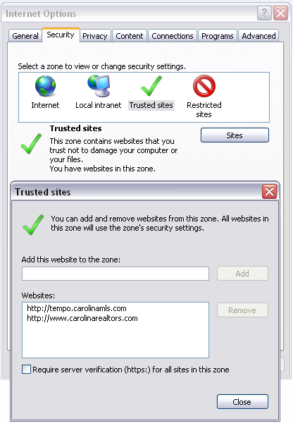

Configuring privacy

To allow TEMPO to communicate properly with your computer, it must be “allowed” in your privacy settings.
- From Internet Explorer, select “Tools” and “Internet Options.”
- Select the Privacy Tab.
- Click the “Sites” button, then add each of the following two sites, clicking the “Allow” button after each:
  - Carolinamls.com
  - Safemls.net
- Click “OK” when you are done.

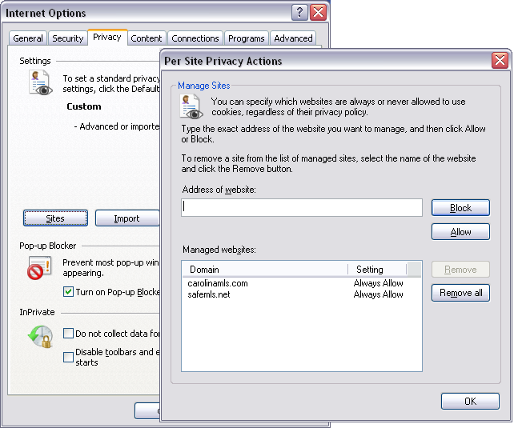

Configuring advanced options

Many third-party extensions to Internet Explorer can cause errors in TEMPO. Disabling these programs will bypass any issues they may cause.
- From Internet Explorer, select “Tools” and “Internet Options.”
- Select the Advanced Tab and scroll to the “Browsing” section
- Uncheck “Enable this party browser extensions.”
To enable the TEMPO system files to be cached (saved) for faster access, follow these steps:
- Scroll to the security section of the “Advanced” tab.
- Uncheck the option “Empty temporary Internet Files Folder when browser is closed.”
- Click “Apply,” “OK,” and then close and restart the browser.

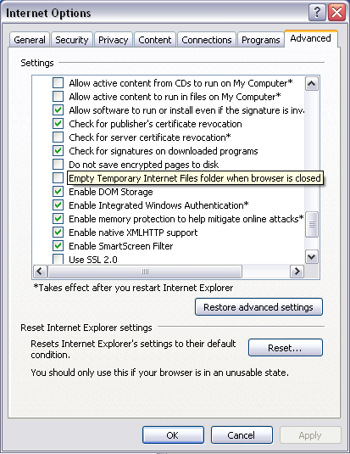

Installing ActiveX controls

ActiveX Controls are required to use all functions of TEMPO. Once you are logged into the system, complete the following to install the ActiveX system components:
- Click on “My Sidebar” (in TEMPO). This will take you to the CMLS links. At the very top, you will see the “TEMPO™ 5 Documentation” header.
- Click on “TEMPO™ 5 ActiveX Controls” just below the header. This will open the window as shown below.
- Click “Install.” At this point, you may see the message below:

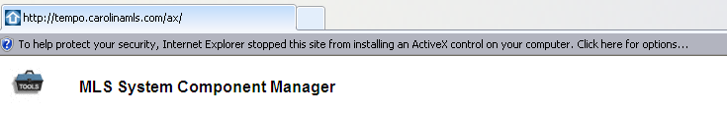

- If this message appears, click on the bar, then click “Install this add-on” in the menu. Click the “Install” button on the page again.
- A series of different windows will appear to install each system component. ActiveX files need only be installed once and require you to agree to the install when prompted. These will need to be installed on each PC that accesses TEMPO.

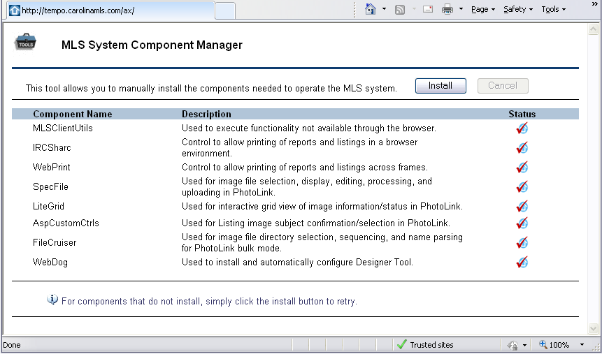

More information on ActiveX controls

ActiveX controls are small programs, sometimes also called add-ons, that are used to enhance your browsing experience by allowing animation, or they can help with tasks such as installing security updates.

Some websites require you to install ActiveX controls to see the site or perform certain tasks. TEMPO uses ActiveX controls to deliver convenient and necessary additional functionality such as printing reports and viewing of listing images. ActiveX controls can only be installed if you are logged in as the administrator of the PC (in most cases, when you log in to your home PC, you are more than likely logged in as the administrator).

A note on general Internet Explorer maintenance

Below are instructions on clearing the “cache” in Internet Explorer. This process will become necessary from time to time to ensure that your computer is always up-to-date with the most current information available on a website. There is no need to do this on a daily basis or any other set schedule; instead, this is a simple process to complete when certain websites begin displaying errors, are loading abnormally slowly, or you are having issues logging in to many sites.

Depending on the version of Internet Explorer being used, there can be a slight variation in the way this process is done. To find out which version you are using, click the “Help” menu at the top left-hand corner of your screen and select “About Internet Explorer.” The large number next to the IE logo, or the first number where it says “Version” will tell you if you are using version 6, 7 or 8. Close the help window and you can now continue with clearing your temporary files.

From the menu bar at the top of Internet Explorer, choose “Tools” then “Internet Options.”

For version 6:
In the middle of this window you will see two buttons marked “Delete Files” and “Delete Cookies.” Click one, click “OK” when asked, then click the other and click “OK” when asked.

For version 7:
You will see a button marked “Delete” in the center of this screen. Click this to open a new window with the two buttons marked “Delete Files” and “Delete Cookies.” Click one, click “OK” when asked, then click the other and click “OK” when asked.

For version 8:
You will see a button marked “Delete” in the center of the screen. Click this to open a new window with checkboxes for “Delete Files” and “Delete Cookies.” Make sure these are the only two boxes checked and that all others are blank. Then click “Delete” at the bottom of this screen.

When this is done, click “OK” to close out of the “Internet Options” window, and then close ALL open Internet Explorer windows.

