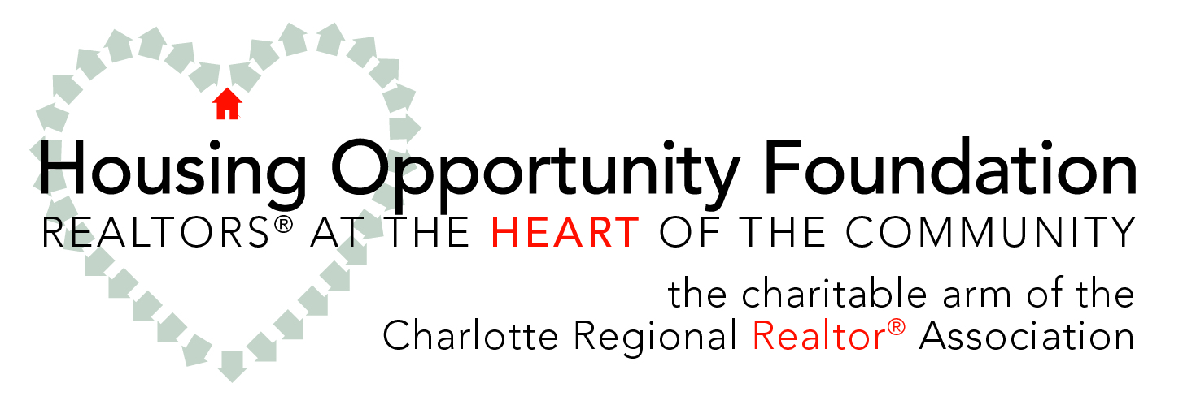

Community Grants Program

Fiscal Year 2015

APPLICANT INFORMATION SHEET

Applicant: _______________________________________________________

Address: _________________________ City/State/ZIP: _________________

Contact/title: _______________________________________________________

Phone number: _______________________________________________________

E-mail address: _______________________________________________________

Fax: _______________________________________________________

Date of application: _______________________________________________________

SUPPORT INFORMATION

In the space below, summarize in one concise sentence how these dollars will be used, as well as the amount of your request.

NARRATIVE
Using the following questions as a guide, briefly describe how these funds will be utilized by your organization. Please keep your responses brief and limit narrative to no more than three pages.

- Describe in detail how these funds will help your nonprofit organization to accomplish its mission as it relates to unmet housing concerns (include any pertinent timelines, locations, goals and central partnerships).
- Describe how the usage of these funds will address a unique housing need.
- Clearly identify your target audience(s) and why they are important to your organization, particularly as they are affected by this funding.
- Explain how you will ultimately track and evaluate the effectiveness of this funding.
- Budgets: 1) Include the specific project budget for the subject of your application; and 2) Include an overall organizational budget that includes other sources of revenue for your organization.
- Include any other select information or attachments that would help the Housing Opportunity Foundation to understand your utilization of these funds.
- REQUIRED: Please include a letter of recommendation from a Realtor® in good standing who is currently a member of the Charlotte Regional Realtor® Association; applications without this letter will be considered incomplete.

HOUSING OPPORTUNITY FOUNDATION

VISION Realtors® affecting a better quality of life in the region

MISSION Promote homeownership, provide funding to create housing opportunities, and position and education Realtors® as leaders.

www.CarolinaHome.com

Community Grants Program Instructions

Purpose
The purpose of the Housing Opportunity Foundation’s Community Grants Program is to provide monetary support to area nonprofit organizations within the scope of the areas served by the Charlotte Regional Realtor® Association (Mecklenburg and Iredell counties only). Only applications for requests that address unmet housing needs will be considered for funding. Applications are rated by a community panel based on the following attributes: community impact, project feasibility, fiscal strength and Realtor® support.

Support amount
The 2015 fiscal year signifies the seventh year for the Community Grants Program. This year, in honor of the foundation’s 30th anniversary, grant requests will be considered in any amount up to $3,000 (pending availability of funds). Support is considered restricted to specific programs and cannot be used for operational, administrative, capital expenses or debt reduction. Exact usage should be detailed in the attached narrative.

Application details
For the 2015 fiscal year, the support will be distributed in the third quarter during the month of September; the funding must be expended by Dec. 31, 2015. Only legally recognized nonprofit organizations operating in Mecklenburg and Iredell counties are eligible. Please note that Habitat for Humanity organizations are not eligible for funding through this program and should inquire about the Habitat Support Program. All applications must be accompanied by a letter of recommendation by an active Realtor® member of the Charlotte Regional Realtor® Association; the member must be in good standing at the time of application.

Submission deadline
To formalize accounting processes and procedures, each applying organization is asked to submit brief documentation as part of the application process. No late applications will be accepted.

Submission deadline: Checks distributed by:

July 31, 2015 Sept. 9, 2015

Reporting
The foundation, as the manager of this grant program, reserves the right to request additional year-end reports to certify that the funds were dispersed as proposed; this provides assurance that the funds served the organizational purpose as stated. Failure to submit these reports could jeopardize an organization’s ability to receive funds in future grant cycles.

Submission checklist
_____Applying organization information sheet
_____Completed narrative
_____Certification of tax-exempt status
_____Realtor® recommendation letter

E-mail, mail or fax completed applications to:
Terri Marshall (terri.marshall@carolinahome.com)
1201 Greenwood Cliff, Ste. 200 704-940-3148 (phone and fax number)
Charlotte, NC 28204

